HandsMen Threads: Elevating the Art of Sophistication in Men's Fashion

Project Overview
HandsMen Threads is high-end and luxury organization in the fashion industry, currently they are in a transition to implement transformative Saleforce solutions to streamline data management, ensure data integrity, and elevate customer relationships in the fashion industry. The project establishes a comprehensive data model to centralize all business data, enabling seamless information flow and supporting data-driven decision-making across the organization.
The HandsMen Thread tailored CRM includes primary custom objects such as Customer, Order, Product, Inventory, and Marketing Campaign. It also utilizes key business activities automations using custom flows such as Record-Triggered Flows, Scheduled Flows, Email Alerts, and Apex Triggers.
This project maintains its integrity and security of data by including role-based security model suited for Maketing, Sales, and Inventory and by also applying strict data validation rules. It also encompasses an Apex process to manage and monitor the stocks in the inventory.
Overall, this project focuses on establishing a robust Salesforce data model and implementing key automated processes to centralize all business data, enhance customer relations, and drive data-driven decision-making for HandsMen Threads.

Objective
The primary objective of this project is to provide the organization a platform that streamlines the business flow, implements strict data security, and enhances customer relationship.
To achieve this goal, the core objectives of this project are:
- Centralize Data: Establish a comprehensive, unified data model for all business data to ensure seamless information flow.
- Enhance Data Integrity: Implement features to maintain the accuracy and consistency of data directly from the user interface (UI).
- Improve Customer Relations: Introduce automated processes to increase engagement and provide personalized customer experiences.
- Boost Operational Efficiency: Automate internal workflows, such as stock alerts and bulk order processing, to optimize operations.
Technology Used with Description
Salesforce
Salesforce is a leading American cloud-based software company best known for its Customer Relationship Management (CRM) platform. It provides a wide range of applications that help businesses connect with their customers and manage key aspects of their operations, including sales, customer service, marketing, and e-commerce, all through the internet (the cloud).
Custom Objects
Custom objects are created to be used by a business-specific information.
Examples:
- HandsMen_Customer__c
- HandsMen_Order__c
- HandsMen_Product__c
- Inventory__c
Profiles
A Profile is a fundamental and mandatory component of the security and user access model. It essentially controls the functional access and user interface settings for a group of users.
Example:
- Platform 1
Roles
A Role is a security and access feature that primarily controls what data a user can see in the organization, specifically at the record level. It is used to create a Role Hierarchy that mirrors your company's organizational chart, often used to determine data sharing and reporting structure.
Example:
- Sales
- Marketing
- Inventory
Permission Sets
A Permission Set is a collection of settings and permissions that allows administrators to extend a user's functional access without changing their assigned Profile.
Example:
- Sales Permission Set
- Marketing Permission Set
- Inventory Permission Set
Validation Rules
Validation Rules are essential tools used to verify that the data a user enters into a record meets specific standards before they can successfully save the record.
Example:
- Email must contain “@gmail.com”
- Stock cannot be 0
- Amount cannot be 0
Email Templates
An Email Template is a pre-designed, reusable structure for composing emails sent from the platform.
Example:
- Order Confirmation Email
- Low Stock Alert Email
- Loyalty Program Email
Email Alerts
An Email Alert is a reusable configuration that defines the email message, its recipients, and the sender, but does not define when the email is sent.
Example:
- Order Confirmation Email Alert – sent when an order is placed.
- Low Stock Email Alert – sent when stock quantity drops less than 5.

Flows
Flow is an application that automates complex business processes by collecting data and then performing actions with that data, all without the need to write traditional code.
Example:
- Order Confirmation Flow (Record-Triggered Flow) – triggered when order status is confirmed.
Apex
Apex is used when the complexity of a business rule or the need for integration exceeds the capabilities of declarative tools

Execution of Project Phase
- A Salesforce Developer Org was created through the link:
https://developer.salesforce.com/signup
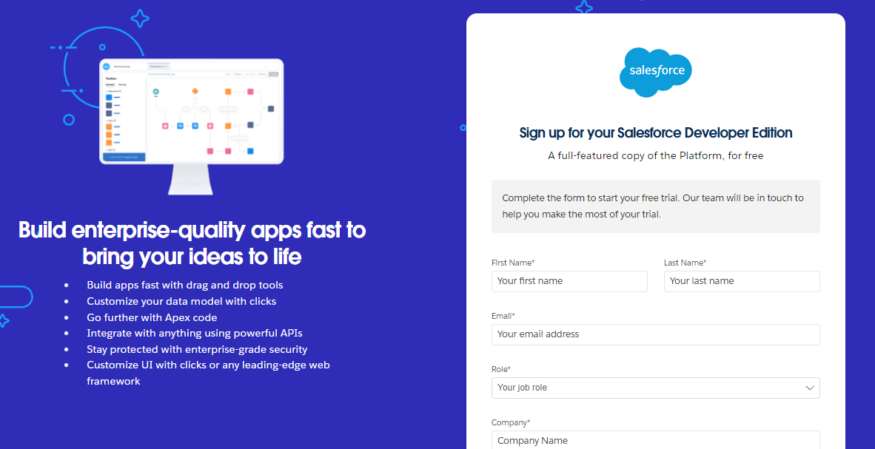
- Custom Object Creation
  - HandsMen Customer – stores customer information such as name, email, phone, and loyalty status.
  - HandsMen Product – stores product catalog details such as SKUs, price, and available stock.
  - HandsMen Order – records customer order information that includes details such as customer name, product, quantity, status, and order date.
  - Inventory – monitors and tracks each product’s stock quantity and warehouse location.
  - Marketing Campaign – stores details such as schedule and target audience of a campaign.
- Creating the Lightning App
  - Create a custom lightning app that is named HandsMen Threads to centralized all operations.
  - Its tab includes: HandsMen Order, HandsMen Product, HandsMen Customer, Inventory, Marketing Campaign, Reports, and others.
  - This app is assigned to a System Administrator.
- Validation Rules
This ensures data integrity and enhances data accuracy. Some of the rules implemented are:
  - In Customer Object, email field is validated
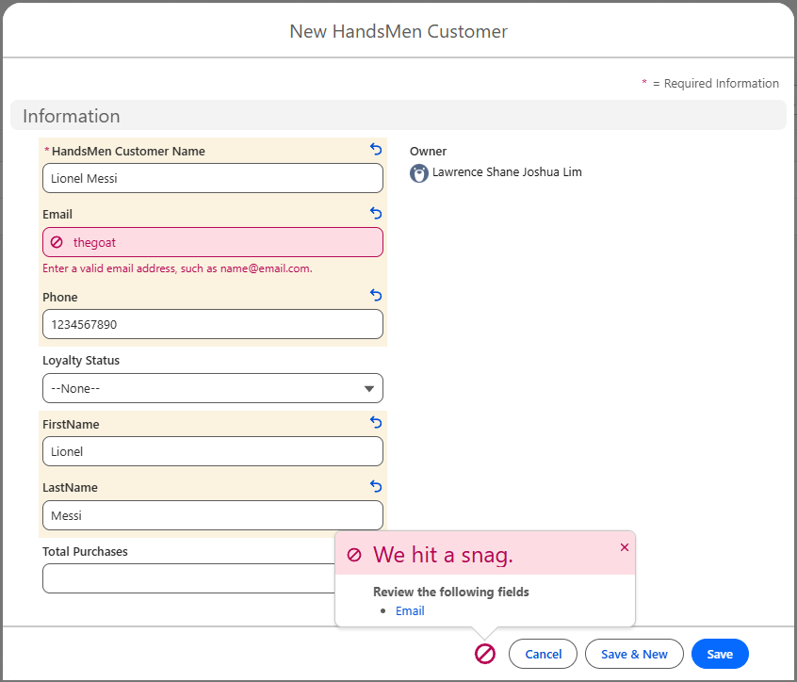
Fig: Customer Object Email Field Validation Rule

- Role and Profile Setup
  - Roles were created for different departments, this are:
    - Sales
    - Marketing
    - Inventory
  - The Profile named ‘Platform 1’ was created from the clone of ‘Standard User’, this gives access to necessary custom object.
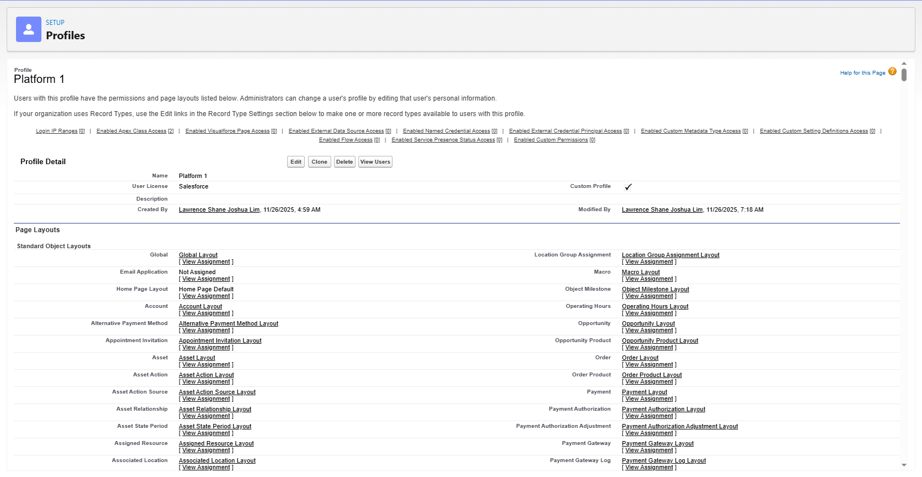
Fig: Profile Platform 1
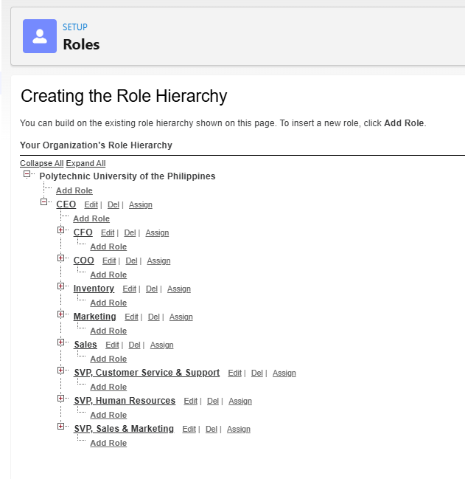
Fig: Setup Roles
- Create Users
  - Users were added and given a profile and role that grants access and proper control
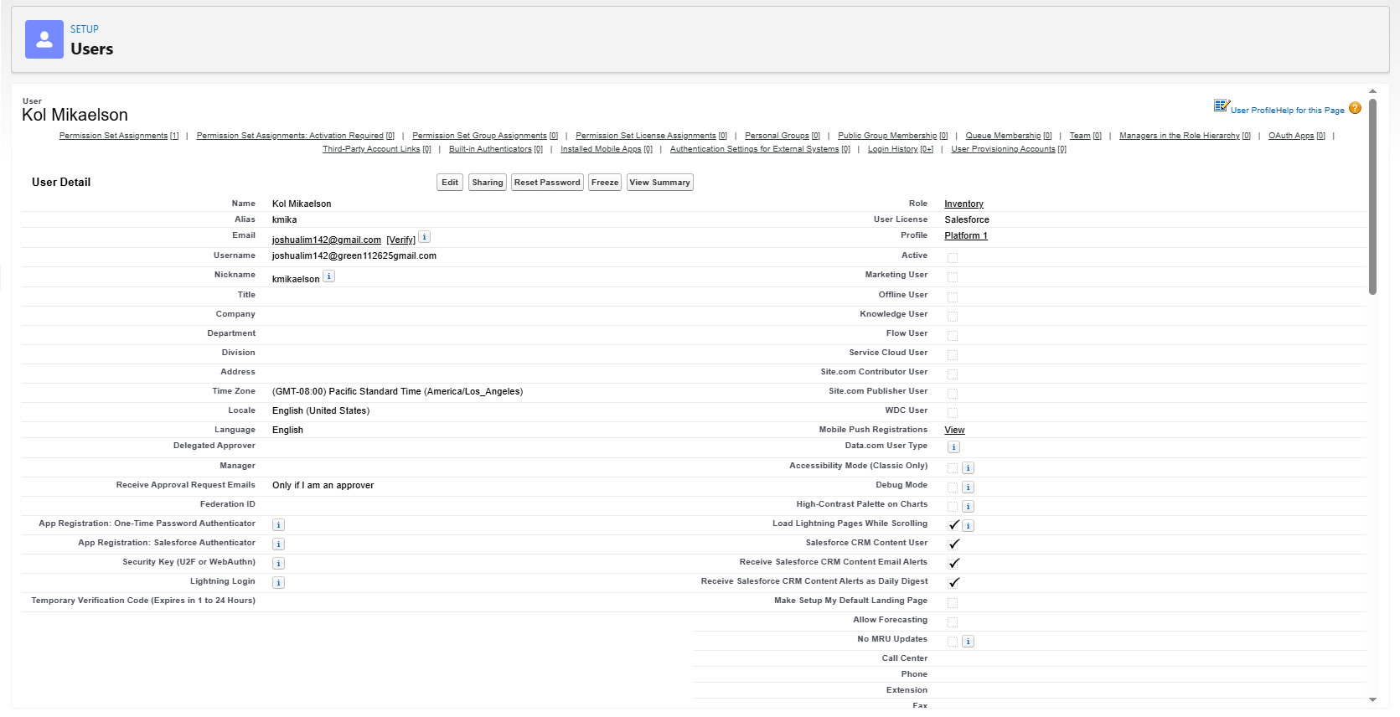
Fig: Setup Users
- Create Classic Letterhead, Email Template, and Email Alerts
  - Create and design Classic Letterhead
  - Create the following Email Template and integrate the Classic Letterhead as needed:
    - Order Confirmation Email
    - Low Stock Alert Email
    - Loyalty Program Email
  - Configure Email Alerts and integrate with flows.
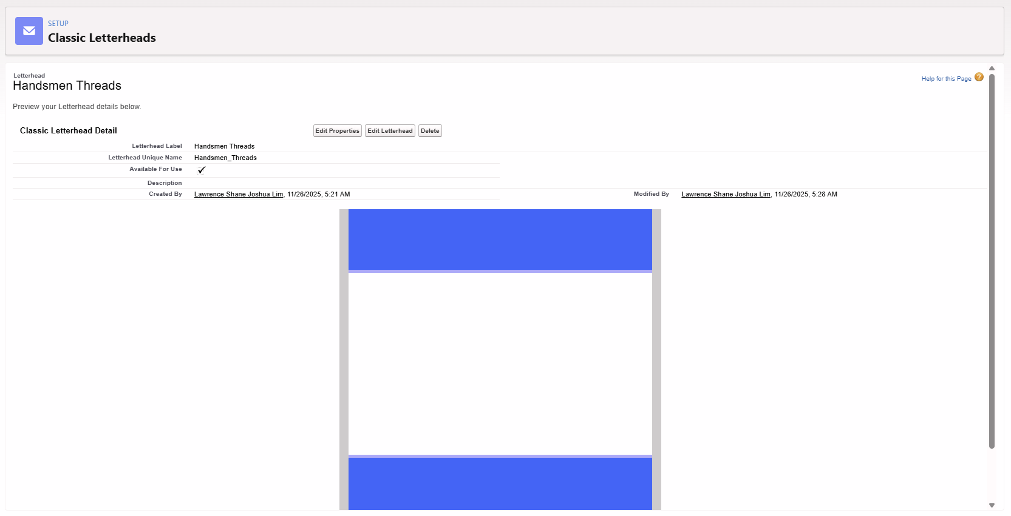
Fig: Setup Classic Letterhead
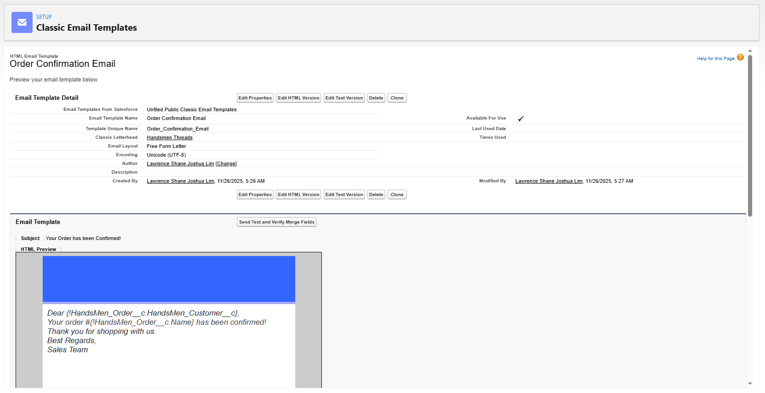
Fig: Setup Email Template

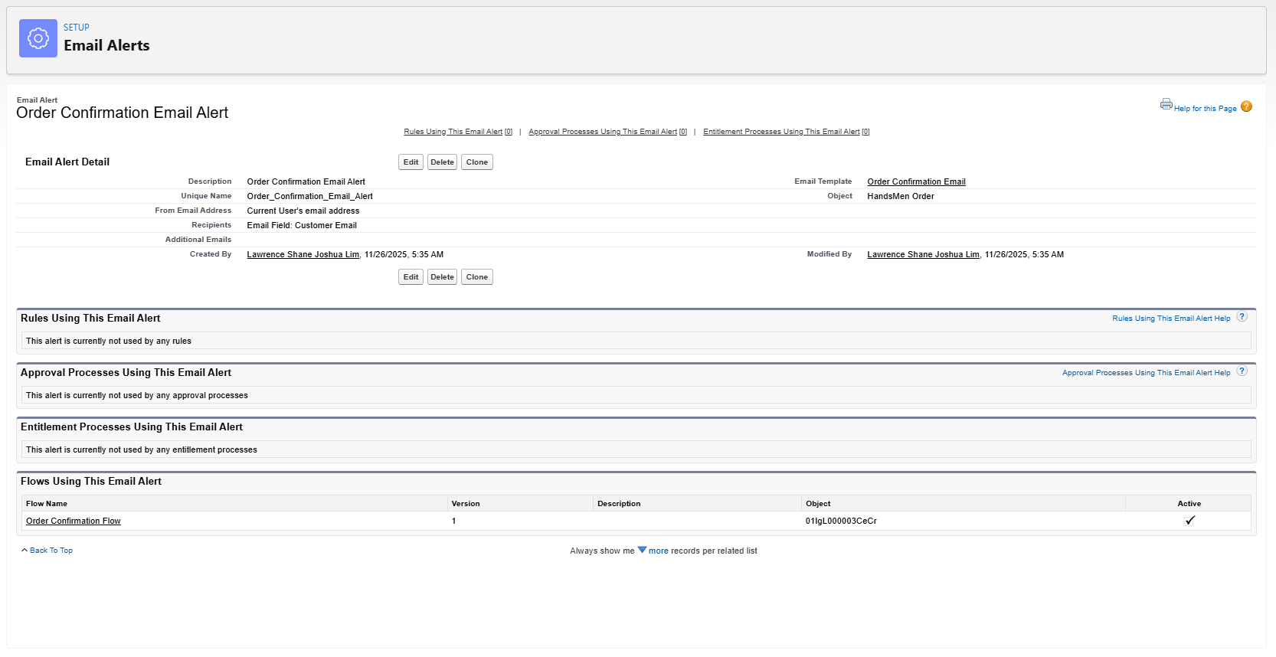
Fig: Setup Email Alert

- Flow Integrations
  - Order Confirmation Flow (Record-Triggered Flow) – sends a customized email to the customer that confirms their order details and status.
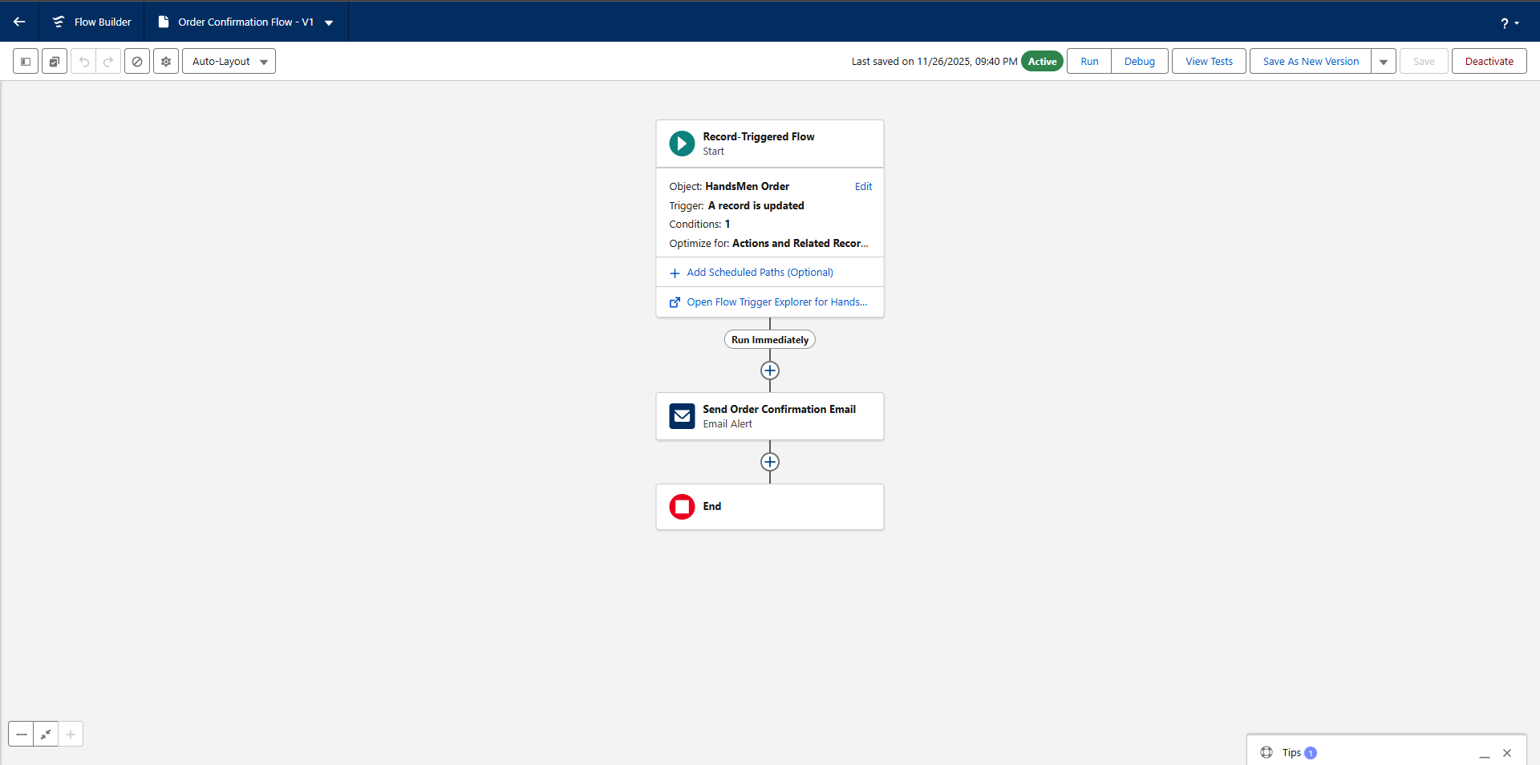
Fig: Order Confirmation Flow

  - Stock Alert Flow (Record-Triggered Flow) – sends an email alerting when stock quantity in inventory drops less than 5.
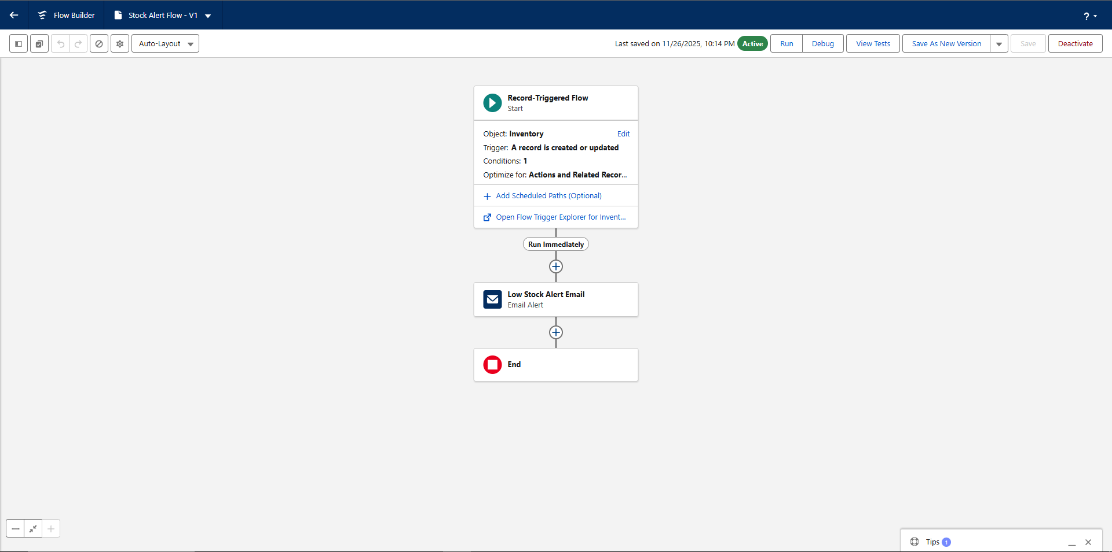
Fig: Stock Alert Flow
  - Loyalty Status Update Flow – this flow sends a personalized email to a customer that is qualified for a certain level of the loyalty program.
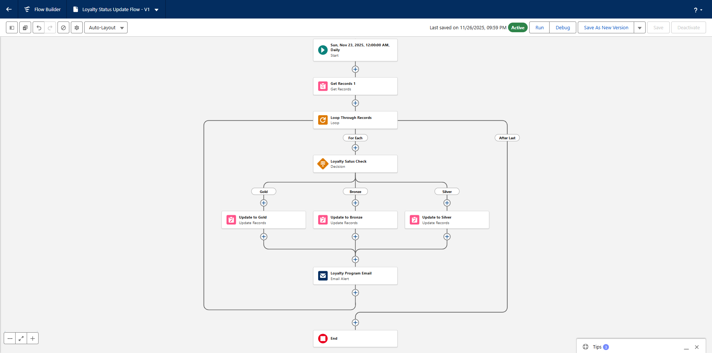
Fig: Loyalty Status Update Flow

- Create Apex Triggers
  - Update Order Total – Object: Order
This auto-update the total amount based on the quantity and product price when saved.
  - Stock Deduction – Object: Inventory
This reduces the stock quantity in inventory when the order status is updated to confirmed.

Screenshots
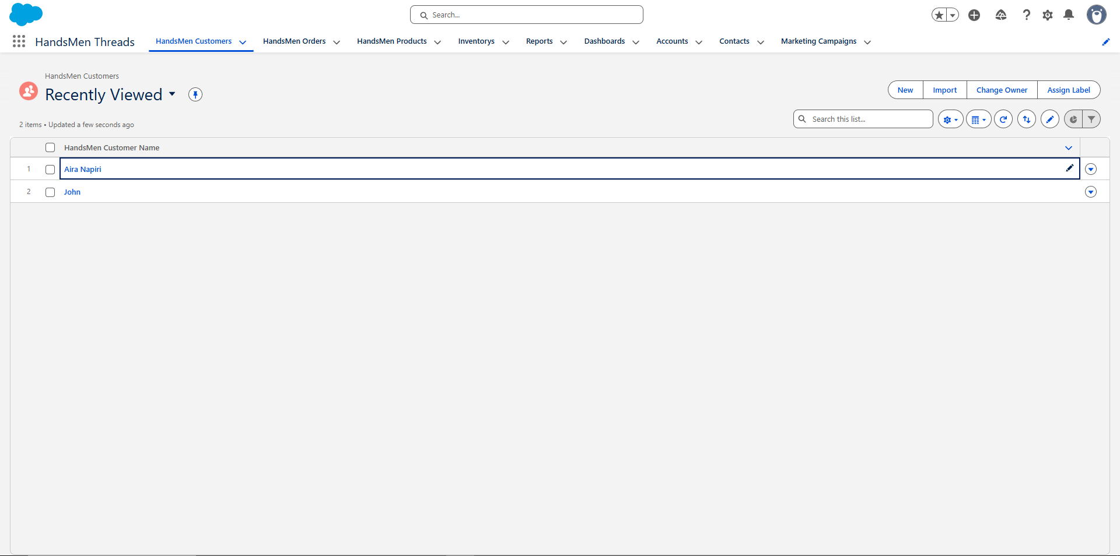
Fig: HandsMen Threads Lightning App

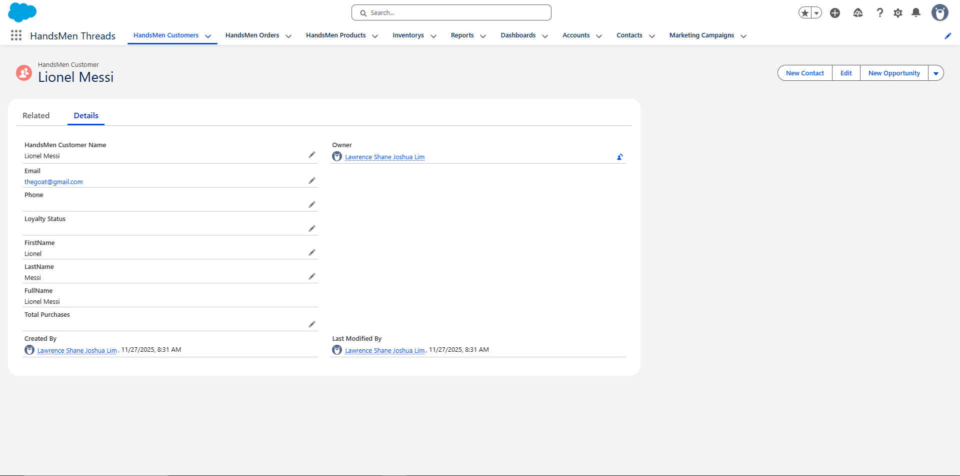
Fig: HandsMen Thread Customer Details

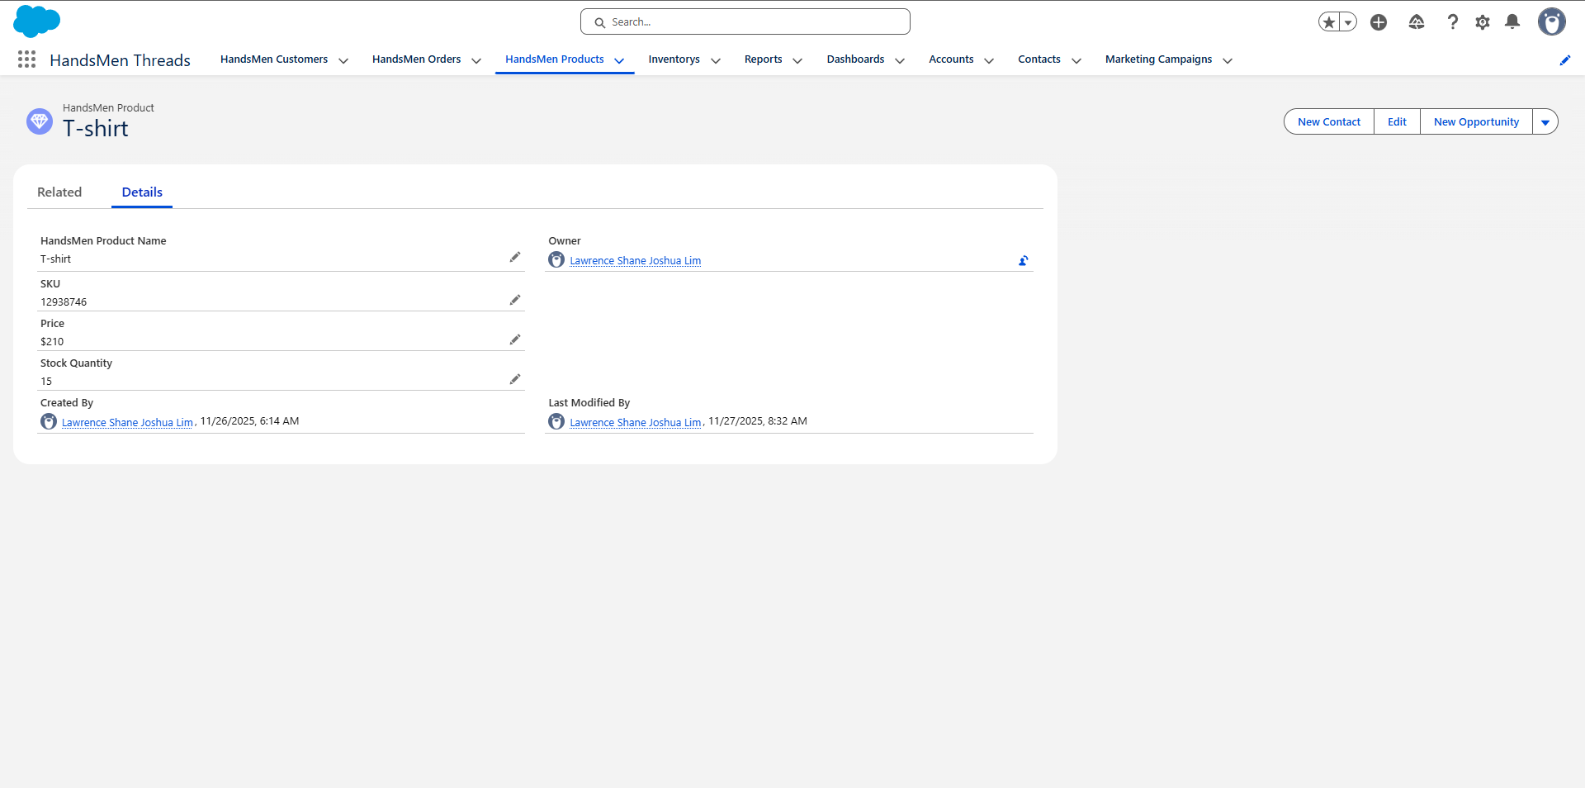
Fig: HandsMen Thread Product Details

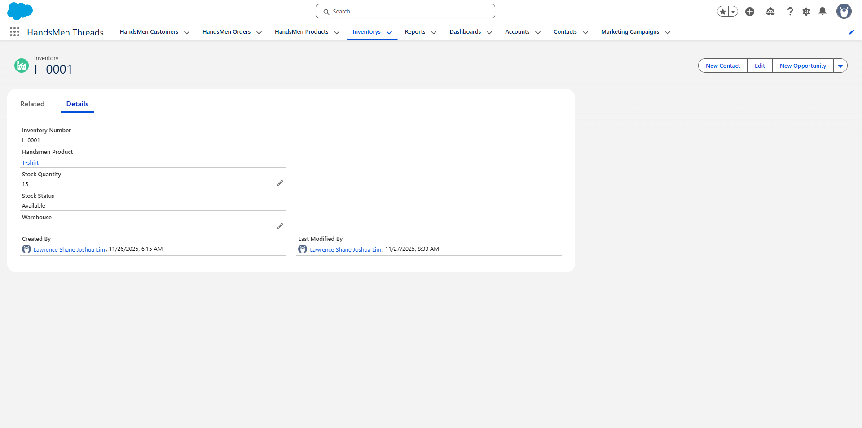
Fig: HandsMen Thread Inventory Details

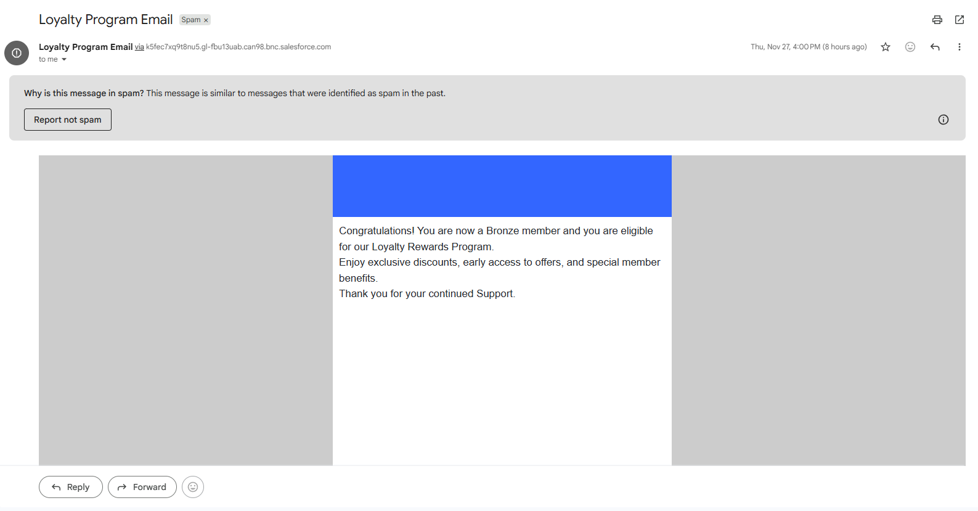
Fig: Loyalty Program Email

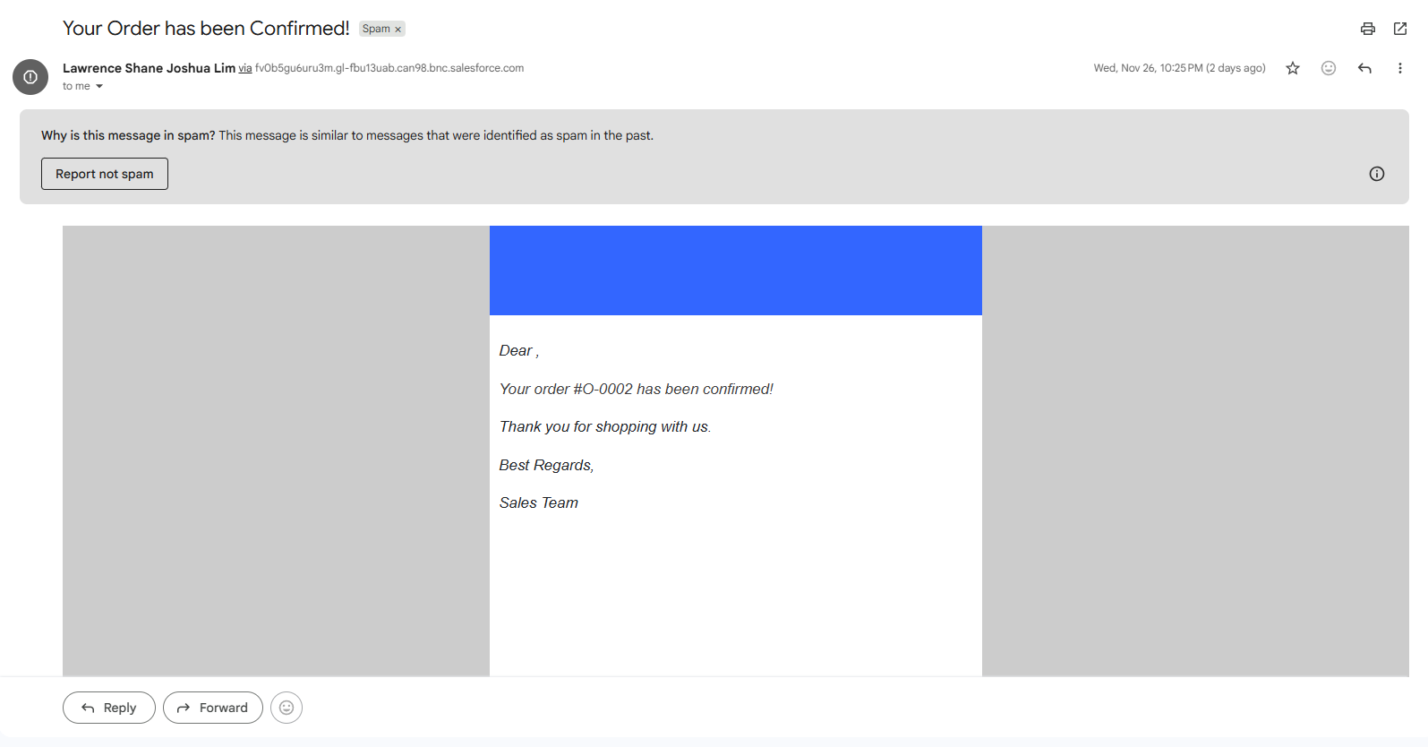
Fig: Order Confirmation Email

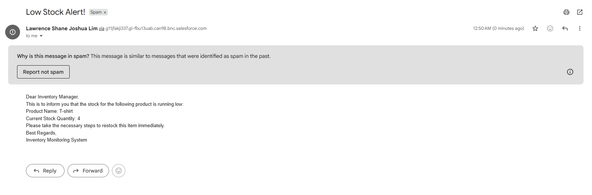
Fig: Low Stock Email

Conclusion
The goal of the HandsMen Threads Salesforce project is to centralize all business data and integrate automation into key processes in order to provide the groundwork for future expansion.
A comprehensive, high-integrity data model that directly supports data-driven decision-making will be the outcome of this project's successful execution. Concurrently, the implementation of procedures such as Order Confirmation Emails, Loyalty Program, and Proactive Stock Alerts will maximize operational efficiency (particularly inventory management and order fulfillment) and greatly improve consumer involvement.
Essentially, this project provides HandsMen Threads with the technological architecture required to guarantee data correctness, promote better customer connections, and accelerate corporate operations.

Future Enhancements
- Mobile App for Sales and Inventory Teams: Give the Sales and Inventory teams mobile access to important data by using the Salesforce Mobile App. For instance, inventory employees may use the mobile app to update the Inventory__c object while doing stock counts on the warehouse floor, while salespeople could check product availability and place orders while driving.
- Inventory Forecasting: Incorporate predictive inventory forecasting into the current Apex stock monitoring process. This would increase operational efficiency beyond basic low-stock alerts by projecting future demand using order history data (HandsMen Order__c) and product details (HandsMen Product__c). This would enable proactive purchasing and production decisions.
- E-commerce Integration: To allow real-time synchronization of product data (HandsMen Product__c), inventory levels (Inventory__c), and customer orders (HandsMen Order__c), integrate the Salesforce solution with an e-commerce platform. This would simplify order capture, do away with human data entry, and provide clients the most recent stock availability.
- Case Management for Defective Products and Returns: Create a structured Case Management process, specifically for handling returns or product quality issues. This would utilize the existing HandsMen_Order__c and HandsMen_Product__c objects to log and track the resolution of defective or returned items.
- Supplier Management: Create a new custom object, to manage relationships with multiple suppliers and manufactures. This will allow for tracking of raw material costs, delivery schedules, and quality assurance records, integrating the supply chain directly into the Salesforce environment.

